Patient Information - Autumn 2026 Covid & Flu Vaccinations

Eligible patients can get their Covid and flu vaccinations this autumn. Clinics will start on 1st October 2026.

We will send invites from Thursday 3rd September 2026 by text or letter. Texts will include a link so you can book your own appointment.

⚠️ Please note: the eligibility rules for the Covid vaccine have changed. Some people who received a Covid vaccine in previous years may not be eligible this autumn.

Who can get the vaccines?

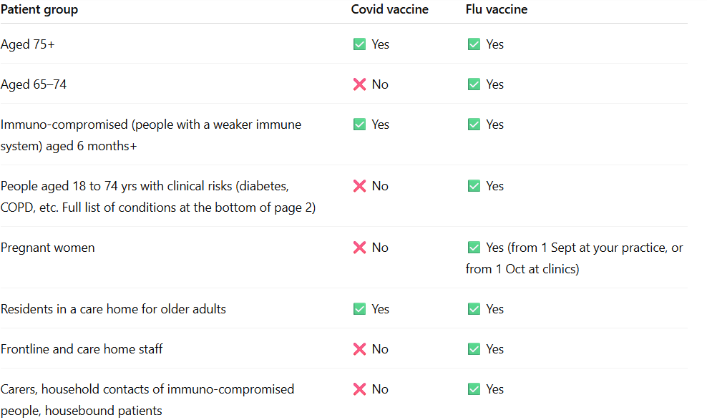

Where can I have my vaccine?

You can book into any practice in our network, not just the one where you are registered, making it easier to find an appointment that suits you.

These are:

- Christchurch Family Medical Practice (Downend)
- The Willow Surgery (Downend)
- The Orchard Medical Centre (Kingswood)
- Leap Valley Surgery (Emersons Green)
- Emersons Green Surgery (Emersons Green)
- Abbotswood Surgery (Yate)
- Pucklechurch Surgery (Pucklechurch)
- Marshfield Community Centre (Marshfield)
- Wick Surgery (Wick patients only – phone invite) (Wick)
- Colerne Surgery (Colerne patients only – phone invite) (Colerne)

Appointments will be available on weekdays and weekends, including Saturdays and Sundays.

What if I don’t have a mobile phone?

Don’t worry. We will contact all eligible patients, including those who do not have a mobile phone.
You can also call your practice to book.

I am housebound

If you are eligible and housebound, we will contact you to arrange your vaccination.

What if I think I am eligible but haven’t been invited?

If you don’t get an invite by Fri 4th September 2026 and you think you are eligible, please call our reception team.

More information

For the latest details, visit:
- NHS Covid - https://www.nhs.uk/vaccinations/covid-19-vaccine/
- NHS Flu - https://www.nhs.uk/vaccinations/flu-vaccine/

Clinical risks for people aged 18 to 74 yrs - health conditions that mean you’re eligible for the flu vaccine.

The flu vaccine is recommended for people with certain long-term health conditions, including:

- Conditions that affect your breathing, such as asthma (needing a steroid inhaler or tablets), chronic obstructive pulmonary disease (COPD) or cystic fibrosis.
- Heart conditions, such as coronary heart disease or heart failure.
- Chronic kidney disease.
- Liver disease, such as cirrhosis or hepatitis.
- Some conditions that affect your brain or nerves, such as Parkinson's disease, motor neurone disease, multiple sclerosis or cerebral palsy.
- Diabetes or Addison's disease.
- A weakened immune system due to a condition such as HIV or AIDS, or due to a treatment such as chemotherapy or steroid medicine.
- Problems with your spleen, such as sickle cell disease, or if you've had your spleen removed.
- A learning disability.
- Being very overweight – a body mass index (BMI) of 40 or above.

